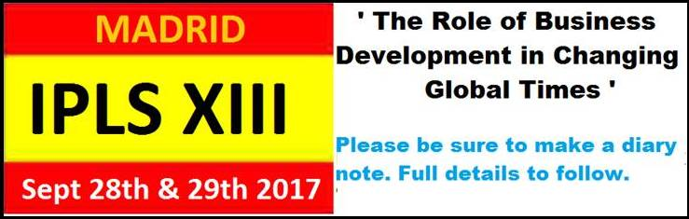

On behalf of the EPLC Committee may I wish you  festive greetings and a healthy and prosperous New Year.

We are pleased to announce the dates for the  20th Anniversary Pharma Licensing Symposium that will be staged in Madrid in September 2017.

IPLS XIII will be focussing on **‘ The Role of Business Development in Changing Global Times’** .

An exciting theme that encompasses a number of hot Topics and how external factors are impacting on the Pharmaceutical Industry as a whole and the BD activities in particular:

**- The impact of Political changes,**

**- The increasing importance of the OTC business,**

**- The impact of Digital Technology ,**

**- The Role of BD in the changing environment**

**- Risk or Opportunity ? – IP & Market Access**

**- Financial Evaluation & Business models**

More details will follow immediately in the New Year including information on our new partnering system offering the opportunity to re-schedule 1:1 meetings in advance or during the event. The programme has been specifically designed to facilitate ample working  opportunities – a key facet of the IPLS Events opening up scores of new BD opportunities.

Please be sure to make a diary note and take advantage of the Early Bird Discount when the Registration desk opens in January. This has to be a ‘**Top Pick Event’ for  2017** if you are involved in Business Development, Licensing & Regulatory affairs.

[Add to Calendar Image.jpg](http://plg-group.com/events/xiii-ipls-madrid/xiii-international-pharma-licensing-symposium-ipls/)

In the interim enjoy the holiday festivities

Merry Christmas